GHANA COMMUNICATION TECHNOLOGY UNIVERSITY
Faculty of Computing & Information Systems
Tesano, Accra • gctu.edu.gh

LECTURE NOTES
Introduction to Software Engineering
ITS 301 / BSc Information Technology — Level 300

Academic Year: 2025 / 2026
Semester: First Semester
Prepared for: BSc Information Technology, Level 300 Students
Department: Computer Science & Information Technology

© 2026 Faculty of Computing & Information Systems, GCTU. All rights reserved.

Table of Contents

Chapter 1: Introduction to Software Engineering

1.1 What is Software Engineering?
Software engineering is the systematic application of engineering principles, methods, and tools to the development and maintenance of high-quality software systems. It is a discipline that combines computer science, mathematics, project management, and engineering practices to produce software that is reliable, efficient, maintainable, and meets user requirements.
The term ’software engineering’ was first coined at a NATO Science Committee conference held in Garmisch, Germany in 1968, organised specifically in response to the so-called ’software crisis’. The discipline emerged as a formal response to the need for rigour, structure, and professionalism in software development.

IEEE Definition
Software Engineering (IEEE Std 610.12-1990): "The application of a systematic, disciplined, quantifiable approach to the development, operation, and maintenance of software; that is, the application of engineering to software."

1.1.1 Software vs. Programs
It is important to distinguish between a program and software. A program is a set of instructions that performs a specific task. Software is a much broader concept that includes executable programs, associated data, configuration files, documentation, and all supporting artefacts that together constitute a deployable, maintainable system.

Concept | Description
Program | A set of coded instructions that performs a specific task
Software | Programs + data + documentation + configuration files
Software Product | Software developed for a specific customer or general market release
Software System | An integrated collection of software components working together
Software Engineering | The disciplined process of building and maintaining software systems

1.1.2 Software Engineering vs. Computer Science
A common point of confusion is the distinction between software engineering and computer science. These are related but distinct disciplines:

Dimension | Computer Science | Software Engineering
Focus | Theory, algorithms, computation | Building practical, reliable software systems
Nature | Primarily academic and research-oriented | Primarily applied and practice-oriented
Key questions | What can be computed? How efficiently? | How do we build large, correct, maintainable systems?
Typical outputs | Proofs, algorithms, models | Software products, architectures, processes
Analogy | Physics (the science) | Mechanical or civil engineering (the application)

In practice, software engineers need a solid foundation in computer science, but their primary concern is with the engineering discipline of building systems that work reliably in the real world, on time, within budget, and to specification.

1.2 The Software Crisis and Origins of Software Engineering
To understand why software engineering exists as a discipline, it is essential to understand the context from which it emerged: the software crisis of the 1960s and 1970s.

1.2.1 What Was the Software Crisis?
As hardware became more powerful and cheaper during the 1960s, organisations began commissioning increasingly ambitious software systems. The results were alarming. Software projects consistently exhibited the following symptoms:
- Projects were delivered significantly late — often months or years behind schedule.
- Projects massively exceeded their original budgets.
- The delivered software frequently did not meet user requirements.
- Software was often unreliable — prone to crashes and unexpected failures.
- Software was almost impossible to maintain — small changes caused unexpected failures elsewhere.
- There was no systematic way to measure or guarantee software quality.

Historical Context
The 1968 NATO conference defined the core problem: the gap between what could be envisioned and what could actually be built was growing faster than the ability to close it.

The phrase ’software crisis’ was coined to describe the systemic failure of the software industry to deliver quality products on time and within budget — a challenge that, in many organisations, persists to this day.

1.2.2 How Software Engineering Responded
Software engineering emerged as the discipline dedicated to solving the software crisis by applying rigorous, systematic, and measurable approaches to software development. Key responses included:
- Formal development processes: Structured methodologies replaced ad hoc coding.
- Requirements engineering: Systematic approaches to capturing and validating what software must do before building it.
- Software design principles: Modularity, abstraction, and separation of concerns to manage complexity.
- Testing and quality assurance: Formal processes for verifying correctness and reliability.
- Project management: Cost estimation models, scheduling tools, and risk management frameworks.
- Professional standards: The ACM/IEEE Code of Ethics and professional certification programmes.

1.3 The Importance of Software Engineering
Modern society is fundamentally dependent on software. Banking systems, healthcare records, transportation networks, communication infrastructure, electoral systems, and government services all rely on complex software systems. The consequences of software failure can range from minor inconvenience to catastrophic loss of life and property.

Real-World Example — Ariane 5 (1996)
The Ariane 5 rocket exploded 37 seconds after launch due to a software bug: a 64-bit floating-point number was converted to a 16-bit integer, causing an overflow. The guidance system software had been reused from the Ariane 4 rocket without adequate re-testing in the new context. Cost: $500 million.

Lesson: Reusing software without re-engineering it for new requirements is a fundamental software engineering failure.

Real-World Example — Therac-25 (1985-1987)
The Therac-25 radiation therapy machine delivered lethal radiation overdoses to at least six patients due to race conditions in its software. Several patients died. The system had been developed without adequate safety engineering practices.

Lesson: In safety-critical systems, poor software engineering is a matter of life and death.

Software engineering is critically important for the following reasons:
- Economic impact: Software development is a multi-trillion dollar global industry. Poor software quality costs the US economy alone over $2 trillion annually in rework, failures, and lost productivity.
- Safety and reliability: Safety-critical systems — aircraft control, medical devices, nuclear plant management, autonomous vehicles — demand software of the highest quality and reliability.
- Maintainability: Most software will be modified many times during its lifetime. Engineering discipline ensures changes can be made safely without breaking existing functionality.
- Scalability: Professionally engineered software is designed to grow with user needs, whereas ad hoc development produces systems that collapse under growth.
- Security: Software engineering practices — secure design, code review, penetration testing — are the primary defence against the growing threat of cyberattacks, data breaches, and ransomware.

1.4 Types of Software
Software exists in many forms, and each type presents different engineering challenges. Pressman identifies seven broad categories:

Software Type | Description | Examples
System Software | Supports operation of other software and hardware | Operating systems, compilers, device drivers
Application Software | End-user applications for specific tasks | Banking apps, e-commerce platforms, ERP systems
Engineering/Scientific | Computation-intensive scientific and engineering tools | MATLAB, ANSYS, climate modelling systems
Embedded Software | Embedded in hardware with real-time constraints | Pacemaker firmware, car ECUs, ATM software
Web / Mobile Apps | Network-based and mobile applications | Gmail, WhatsApp, mobile money platforms (MoMo)
AI Software | Machine learning, NLP, computer vision systems | ChatGPT, facial recognition, recommendation engines
Cloud-Native Software | Distributed, containerised cloud applications | Netflix microservices, AWS Lambda, SaaS platforms

Understanding the type of software being built is critical: it determines the appropriate development process, architectural patterns, testing strategies, and quality requirements. A cloud-native web application and an embedded pacemaker controller require fundamentally different engineering approaches.

1.5 Characteristics of Software
Software has unique characteristics that distinguish it from other engineered products. Understanding these is fundamental to understanding why software engineering is difficult and why disciplined approaches are necessary.

- Intangibility: Software cannot be seen, touched, or measured in physical terms. Its quality must be inferred from its behaviour, documentation, and the processes used to build it. This makes quality assurance inherently more challenging.
- No physical wear: Software does not wear out or corrode. However, it deteriorates logically — as the environment changes, unchanged software becomes increasingly misaligned with user needs and operational contexts.
- Complexity: Modern software systems are among the most complex artefacts humans have ever created. A modern operating system contains tens of millions of lines of code with intricate interdependencies. Managing this complexity is a central challenge of software engineering.
- Flexibility and malleability: Software can be changed relatively easily compared to physical products. This is both a strength and a risk — it invites scope creep, informal changes, and the accumulation of technical debt.
- Non-linear failure curve: Software failures are triggered by changes, by rare execution paths being encountered for the first time, or by changes in the environment — not by physical wear.
- Discreteness: Software behaviour is discrete, not continuous. A small input change can cause a dramatically different output. This makes exhaustive testing impossible — the input space is effectively infinite.
- Reproducibility: Software can be copied and distributed at near-zero marginal cost. This creates unique economic properties and significant intellectual property challenges.

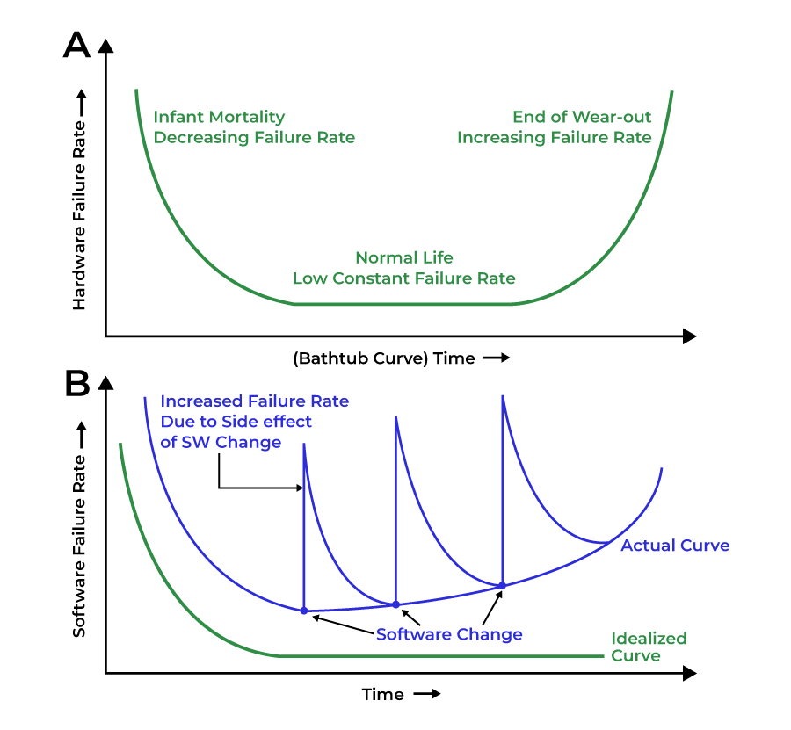
Figure 1.1: Software Failure Curve (vs. Hardware Bathtub Curve)

1.6 Attributes of Good Software
Sommerville identifies five essential attributes that all well-engineered software must possess. These are not optional extras — they are core quality goals that guide every design decision.

Attribute | Definition | Key Questions
Acceptability | Must be acceptable to users — understandable, usable, compatible with their systems | Can users actually use it? Does it integrate with what they have?
Dependability | Reliability, security, and safety — must not cause physical or economic damage on failure | What happens when it fails? Is it safe? Is it secure?
Efficiency | Must not wastefully use system resources such as memory and processor cycles | Does it perform well? Does it scale? Does it use resources wisely?
Maintainability | Must be written so it can evolve to meet changing needs — the largest long-term cost driver | Can it be changed safely? Is it readable? Is it documented?
Usability | Must be easy to learn, efficient to use, and provide a positive user experience | Can new users learn it quickly? Does it minimise user errors?

Key Insight
These five attributes frequently trade off against each other. Maximising security may reduce usability. Maximising efficiency may reduce maintainability. Software engineering is fundamentally about managing these trade-offs intelligently, guided by the specific context and requirements of each system.

1.7 Software Engineering Application Domains
Different application domains place different demands on software engineers. Key domains include:

- Generic products: Standalone systems sold to any customer — e.g., accounting software, word processors. The developer specifies requirements and controls design decisions.
- Customised products: Systems commissioned by a specific client — e.g., a custom hospital management system. The client specifies requirements and controls scope.
- Embedded systems: Software deployed in hardware devices, subject to real-time, power, and size constraints.
- Real-time systems: Systems with strict timing constraints where a late result is as bad as a wrong result — e.g., aircraft autopilot, industrial control systems.
- Safety-critical systems: Systems where failure could result in injury, death, or catastrophe — e.g., nuclear plant control, railway signalling. Subject to formal certification.
- Legacy systems: Old but operationally essential systems that must be maintained and evolved despite outdated technology.
- Web and mobile applications: Distributed, network-dependent systems with high usability and performance demands — the dominant application domain of modern software engineering.

1.8 Professional and Legal Responsibilities
Software engineers work within a framework of professional and legal responsibilities that extend beyond writing correct code. These responsibilities are increasingly important as software becomes embedded in critical infrastructure and daily life.

1.8.1 Intellectual Property and Copyright
Software is protected by intellectual property law. Key concepts include:
- Copyright: Source code is automatically protected by copyright from the moment it is written. Using another person’s code without appropriate licensing is a legal violation.
- Software licensing: Proprietary licences restrict use and distribution. Open-source licences (MIT, GPL, Apache) permit use under defined conditions. Engineers must understand licences of all third-party code they incorporate.
- Patents: Software patents protect specific algorithms or methods. In some jurisdictions, software is patentable, creating legal risks if similar approaches are independently developed.
- Trade secrets: Confidential algorithms, architectures, and business logic are protected as trade secrets. Engineers have a duty of confidentiality to their employers.

1.8.2 Confidentiality and Data Protection
Software engineers routinely work with sensitive data — personal information, financial records, medical data. Professional and legal obligations include:
- Maintaining strict confidentiality of client and employer data, even after leaving employment.
- Complying with data protection legislation such as Ghana’s Data Protection Act 2012 (Act 843) and the EU’s GDPR when handling personal data.
- Implementing appropriate technical controls — encryption, access controls, audit logging — to protect data from unauthorised disclosure.

1.8.3 Computer Misuse and Cybercrime
In Ghana, the Electronic Transactions Act 2008 (Act 772) and the Cybersecurity Act 2020 (Act 1038) define criminal offences including: unauthorised access to computer systems, unauthorised modification or destruction of data, creation and distribution of malware, and online fraud. A software engineer who discovers a security vulnerability has a professional obligation to report it through proper channels — not to exploit it.

1.8.4 Professional Liability
Software engineers can be held professionally and legally liable for systems they design. Liability arises when a system fails to meet its specifications causing financial loss, when a safety-critical system fails due to engineering negligence, or when false claims are made about a system’s capabilities. Professional indemnity insurance, rigorous documentation, and formal testing are the engineer’s primary protections against legal liability.

1.9 Software Engineering Ethics
Professional software engineers have ethical responsibilities that extend beyond technical competence. The ACM/IEEE-CS Software Engineering Code of Ethics and Professional Practice (1999) identifies eight principles:

Principle | Summary | Practical Meaning
1. Public | Act in the public interest | Prioritise societal benefit over employer or client demands when they conflict
2. Client & Employer | Act in their best interest | Be honest about capabilities; do not work against those who employ you
3. Product | Ensure highest professional standards | Only approve work you believe to be correct, safe, and of good quality
4. Judgment | Maintain professional integrity | Do not allow commercial pressures to compromise your professional judgment
5. Management | Promote ethical management | Ensure those you manage have what they need to work ethically
6. Profession | Advance the profession | Avoid actions that damage software engineering’s reputation
7. Colleagues | Be fair and supportive | Share knowledge, credit others, and do not undermine colleagues
8. Self | Commit to lifelong learning | Continuously improve your technical and professional skills

Ethical Dilemmas in Practice
Software engineers frequently face genuine ethical dilemmas:

- A client asks you to build a system that is legal but could be used to deceive consumers.
- Your employer asks you to sign off on software you believe is unsafe to meet a deadline.
- You discover your company has suffered a data breach and is concealing it from affected users.
- You are asked to build surveillance software to monitor employees without their knowledge.

The ACM/IEEE Code provides a framework: the public interest always takes priority.

1.10 Modern Software Engineering — Contemporary Challenges
The discipline of software engineering continues to evolve rapidly. L300 students must be aware of contemporary developments reshaping how software is built and managed:

1.10.1 AI-Assisted Software Development
Artificial intelligence tools — including GitHub Copilot and large language models — are increasingly used to assist with code generation, documentation, and debugging. Key considerations:
- AI-generated code must be reviewed, tested, and validated by engineers — AI does not eliminate the need for engineering judgment.
- Copyright and licensing of AI-generated code is legally uncertain in many jurisdictions.
- AI tools can propagate security vulnerabilities and code quality issues if outputs are accepted uncritically.

1.10.2 DevOps and Continuous Delivery
DevOps unifies software development and IT operations to enable faster, more reliable software delivery. Key practices include Continuous Integration (CI), Continuous Delivery (CD), Infrastructure as Code (IaC), and real-time production monitoring.

1.10.3 Open Source Software
The majority of modern software systems are built on open source foundations. Engineers must understand how to evaluate and integrate open source projects, the licensing obligations of different open source licences, and the supply chain security risks introduced by third-party dependencies.

1.10.4 Cloud Computing and Distributed Systems
The shift to cloud infrastructure has transformed software architecture. Modern software engineers must understand cloud service models (IaaS, PaaS, SaaS), distributed systems concepts (CAP theorem, eventual consistency), containerisation (Docker, Kubernetes), and serverless computing architectures.

1.10.5 Cybersecurity Engineering
Security must be engineered into software from the beginning — not added as an afterthought. Engineers are expected to understand secure design principles (least privilege, defence in depth), common vulnerability classes (OWASP Top 10), and security testing practices (penetration testing, static analysis, dependency scanning).

1.11 The Software Engineer as a Professional
Software engineering is a profession — not merely a technical skill. What distinguishes a professional software engineer from a programmer is not just technical ability, but adherence to a broader set of professional obligations:

Dimension | Programmer | Professional Software Engineer
Focus | Write code that works | Build systems that are correct, safe, maintainable, and ethical
Scope | Individual task | Full lifecycle — from requirements to retirement
Responsibility | To the immediate task | To users, clients, employers, colleagues, and the public
Quality standard | Works on my machine | Works reliably, securely, and correctly in production at scale
Change management | Edit and hope | Version control, testing, code review, formal release management
Documentation | Minimal or none | Comprehensive — requirements, design, code, user guides
Professional development | Learn as needed | Committed to continuous learning and currency in the discipline

Chapter 1 Summary
This chapter has introduced software engineering from its historical origins to its contemporary challenges. The key points to retain are:
- Software engineering is the systematic application of engineering discipline to software development and maintenance — distinct from and broader than programming.
- The discipline emerged from the software crisis of the 1960s, which demonstrated that ad hoc development was inadequate for building large, reliable systems.
- Software has seven unique characteristics — intangibility, no physical wear, complexity, flexibility, non-linear failure, discreteness, and reproducibility — that make engineering discipline essential.
- Good software must be acceptable, dependable, efficient, maintainable, and usable. These attributes trade off against each other and managing those trade-offs is a core engineering skill.
- Software engineers carry professional and legal responsibilities in intellectual property, confidentiality, computer misuse law, and professional liability that extend beyond technical competence.
- The ACM/IEEE Code of Ethics provides an eight-principle framework for professional conduct, with the public interest always taking priority.
- Contemporary developments — AI-assisted development, DevOps, open source, cloud computing, and cybersecurity engineering — are expanding what every software engineer must know.

